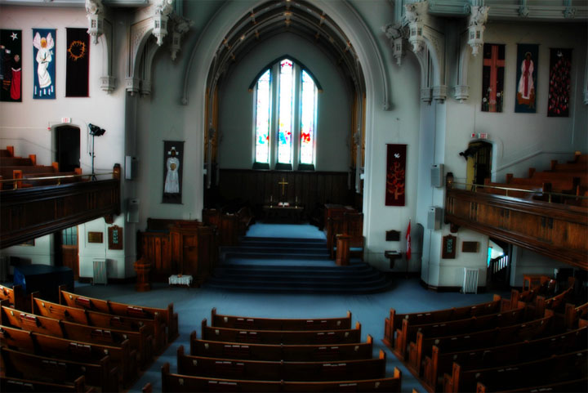

We’re delighted that you plan to be married at Knox United Church. We believe that the service of marriage and all of its component parts should be so arranged as to convey a sense of unity, Christian commitment, and spiritual awareness of God’s presence. It is not required that the couple be members of Knox United Church or any church.
The date and time of a wedding to be held at Knox United Church may be reserved by contacting the church administrator at (306) 244-0159. The confirmation of this time and date will be made through our church administrator. It is important to arrange for an interview with the minister about two months before your wedding date.
If there is any change in your plans, please notify the church office as soon as possible.

MARRIAGE PREPARATION
Marriage Preparation courses and resources can be very valuable and insightful for couples as they begin married life together. If you would like information about resources available through Knox, please speak to the minister to make arrangements.

MUSIC
Music is a wonderful element of a wedding service. It’s important to choose music thoughtfully to reflect the spiritual nature of your wedding service. The Knox organist and minister will review and approve your music selections, so you will need to discuss music with them several weeks prior to the wedding.
We have an incredible pipe organ or piano available, and our organist/pianist, Patricia Deibert (306-373-1619), is available to play for all weddings. Many couples choose to have her play the processional (when the wedding party enters) and the recessional (when the wedding party leaves), along with other music through the service. She can help you choose uplifting and celebratory music.
Knox can also accommodate recorded music (CD or MP3). Additional music (vocal or instrumental) can be included in your service, and the organist can often assist with arranging that if you wish.

DECORATIONS, FLOWERS, CANDLES and CONFETTI
The Sanctuary at Knox is a beautiful space for wedding services. In consultation with the Minister, you are welcome to bring additional decorations for your special day. Please remember that Knox can be a busy place, so couples should plan adequate time for setup and removal of decorations.
Candles can add to the beauty of a wedding in a candle ritual or display. We ask that you purchase non-drip candles for such use.
Live flower petals or confetti may not be used inside or outside the church building. Artificial flower petals are acceptable (if you arrange to have them gathered and removed after the service). Please make this known to your guests and wedding party

REHEARSAL
A rehearsal for your wedding is essential. All those directly involved should be present: bride and groom, bridesmaids, groomsmen, flower-girl(s)s, ring-bearer(s), ushers, and parents of both the bride and groom. Normally the organist will not attend the rehearsal. The time for your rehearsal is usually decided when you meet with the minister. Normally the rehearsal is late afternoon or early evening on either the Thursday or Friday before the wedding.

FEES
The fee for a wedding at Knox United Church are $990.00. This fee includes the honoraria for the minister, all other required staff, the church facility, and complete legal administration.
A non-refundable deposit of $200.00 is required at the time of booking the wedding. It is payable (cash, cheque, or e-transfer) to Knox United Church and will confirm all facilities as arranged through the church administrator. The deposit is non-refundable.
The remainder of the fees ($790.00) should be brought to the church office no later than one month prior to the wedding date.
Please be sure to contact the church office if your wedding date or any other arrangements need to be changed.

MARRIAGE LICENSE
A Saskatchewan Marriage Licence MUST be purchased well in advance of the wedding. This may be purchased at jewellery stores, wedding boutiques, or other official issuers. It is valid only for three months prior to your wedding date.
Please bring your Marriage Licence and all remaining fees to the church office no later than one month prior to your wedding date. (preferably as soon as you have it).

For more information on marriages in Saskatchewan, call @ 1-855-347-5465 or visit www.ehealth.ca/vitalstatistics/marriages
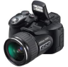

PHOTOGRAPHS & VIDEO

Please forward this information to your photographer/videographer.
Knox United Church, its ministers and staff work cooperatively with you and your photographer(s) to ensure that you receive great quality photographs of your wedding. Please feel free to ask about any special photo requests not mentioned here.
It is important for your photographer to contact the minister on arrival at the church or, even better, to come to the rehearsal to plan their movement for the wedding.
Generally, photographs may be taken anywhere in the sanctuary and church building, at whatever moments the photographer desires. Your photographer is free to move throughout the space as they wish to take photos throughout the whole service. Thoughtfulness and sensitivity to the sacred nature of your wedding service are expected.
Video photography must be arranged with the minister well before the time of the wedding. In general, it should be non-interfering and unobtrusive. The Minister can suggest several suitable video locations.

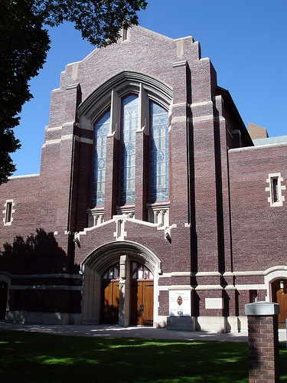

WEDDINGS
at
KNOX UNITED CHURCH

838 Spadina Crescent East
Saskatoon, SK S7K 3H4
Tel (306) 244-0159
Email: info@knoxunitedchurch.ca

Sharing the Gospel of Jesus with all people through worship, service and care

